Discovering the Renaissance: Research Activity
O England! model to thy inward greatness,
Like little body with a mighty heart…
-William Shakespeare
Your Objective: You will work in small groups to become experts on important historical aspects of the Renaissance that are relevant to our study of literature from this period. You and your partner/s will work together to gather information that you will synthesize into a lesson for your classmates.

When grading this assignment I will be looking to see that your work is clear, compelling and creative and that all members of the group made equal contributions. We will spend a great deal of time in the library. Use this time wisely.
This assignment is divided into two components listed below:

Lesson
You will become an expert on one facet of this diverse and dynamic historical period.

Groups will teach their lessons to the class in a five to eight minute presentation that includes visual aids. Your job is to become the experts and provide a comprehensive lesson for your classmates. Your lesson must be based on research and must include some kind of activity that involves the rest of the class. I will be looking to ensure that all group members contributed equally.

Your lesson must:
- Comprehensively answer all of the focus questions for your topic (see below).
- Involve and engage your classmates in an activity.
- Be creative and informative.
- Be energetic and entertaining.
- Flow naturally, showing you are experts on your topic
- Show that all group members contributed equally.

Visual Aid
You must provide physical evidence of your research into your topic. Each group must submit the following:

- Some physical, written evidence of your work. This will vary from group to group, but must be clear, concise, informative and relevant. If you choose to publish your information in the form of a brochure, provide me with a copy. If you chose to write a song, provide me with a copy of the lyrics. If you choose to perform a skit, print a copy of the script for me. Be creative. PowerPoints are boring!
- A Works Cited page including at least 4 reputable sources in MLA format, including one source that is accessed from a school-subscribed database. List which books, articles or other works you consulted for your research for this presentation. You may use your Holt book as one of your sources. If you need a refresher on MLA formatting for works cited pages, you may refer to the Purdue Online Writing Lab’s resources or ask your teacher. See also “Citing Sources” in this packet.
- A Note on sources: Your Holt Elements of Literature book may be used as one source. The others may be either print or web sources, but must be reliable and appropriate for scholarly research. Remember that Wikipedia is not a legitimate source for research. Remember that when collecting information for this project it is important to evaluate sources for legitimacy. Blogs, personal websites and sites from unknown and unreliable sources are not appropriate for scholarly work. Points will be deducted for use of unreliable sources.

Discovering the Renaissance: Research Activity Rubric
 | Process | Presentation: Content | Presentation: Execution | Presentation: Interactivity | Visual Aid | Research
A | Group works together to overcome problems and challenges and uses all available class time.  20 | Students are experts on their topic. All relevant information is covered in detail and questions answered.  10 | Lesson is led naturally, professionally and with confidence. Students know the information they present with minimal reference to notes.  10 | Presentation involves the rest of the class in some creative, entertaining way that is relevant and well tied to the lesson. Class well motivated to participate.  20 | Eye-catching visual aid is comprehensive, creative, clear and informative and enhances the lesson.  20 | All sources are cited in MLA format on the Visual aid or on a separate Works Cited page. At least one source is from a school-subscribed database.  20
B | Group works together to overcome problems and challenges and uses most of available class time.  15 | Students appear to know their topic well but some questions remain unanswered.  8 | Presentation is natural and professional but lacking in clarity, energy or confidence. Some reference made to notes.  8 | Presentation involves the rest of the class in a way that is tied to the lesson.  15 | Visual aid provides information that enhances the lesson but isn’t creative or eye-catching.  15 | Source missing and school database not used.  15
C | Group fragmented by problems and challenges. Class time not used wisely.  10 | Many questions left unanswered or topics not covered in detail.  7 | Presentation is mechanical and unenergetic. Students rely too heavily on notes and do not  7 | Class somewhat involved. Lesson is minimally interactive, but not entertaining and energetic or not tied to the lesson.  10 | Visual aid is unclear, dull, or missing critical information.  10 | Sources missing and school database not used.  10
D | Group work not distributed equitably. Too much class time wasted.  5 | Relevant information left out of the presentation. Many questions left unanswered.  6 | Students appear unrehearsed, read from slides and do not appear to be experts on their topic.  6 | Class not involved in any meaningful way.  5 | Visual aid shows minimal effort, seems thrown together and does not provide relevant information or enhance the lesson.  5 | Sources missing and school database not used.  5

Notes:

Discovering the Renaissance: Focus Questions
Directions: Be sure that your presentation completely answers all of the general focus questions and those for your topic. Groups are not limited to these ideas for their lessons! After all students have presented their lessons, each member of the class should have all of these questions answered.
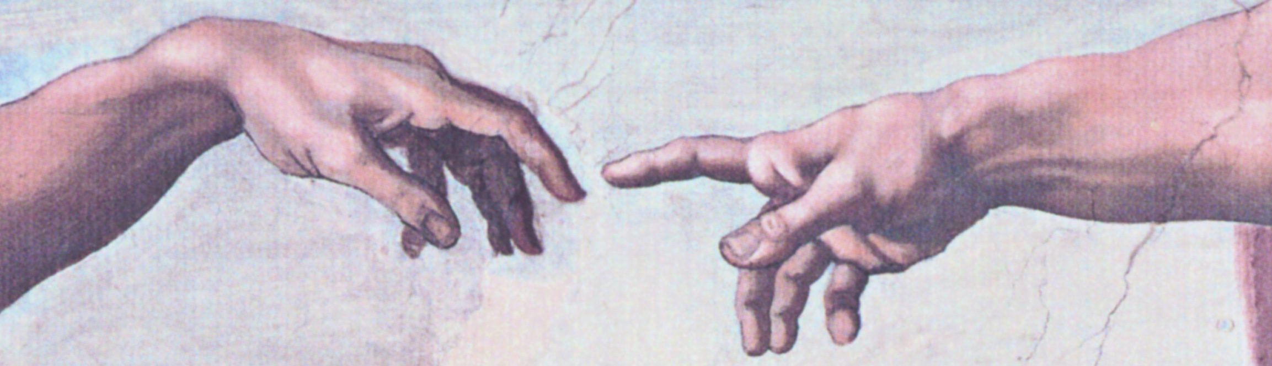
General Focus Questions
What does the word renaissance mean?

What are the approximate dates of the Renaissance in Europe?

Where is this growth and development usually said to have originated?
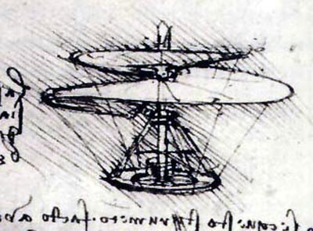

What kinds of things were Europeans primarily concerned with during the
Middle Ages?

During the period known as the Renaissance, Europe saw growth and development
in what cultural fields or disciplines?

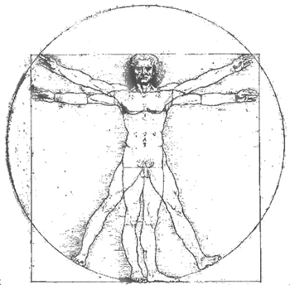

Humanism
What is humanism?

What questions interested the humanist thinkers?

Where did the humanists find the answers to these questions?

Who are two of the most famous humanists and what did they contribute to the Renaissance in Europe?

The Arts, Science and Technology

What languages and disciplines, forgotten during the Middle Ages experienced a resurgence during the Renaissance?

What effect did the Renaissance have on English literature?

Who were some writers and artists who flourished during this time? What are these people known for?

What subjects inspired the art and literature of the renaissance?

What Renaissance invention radically transformed the way people produce and share information? Who was responsible for this invention? When?

What social or cultural changes in Europe resulted from this invention?

What modern invention could be said to have had a similar effect?

What other inventions emerged during the Renaissance? What was the significance of these inventions?

Discovery, Exploration and Colonial Power
What factors acted as the causes or the spark for the spirit of discovery during the Renaissance in Europe?

What two countries emerged as powers during this time period? Which eventually prevailed? How?

What new ideas, peoples and products were introduced to Europe during this period? How did this benefit Europeans?

What effect did European discovery have on the non-European world?

The Church, Religion and the Reformation
What was the Protestant Reformation?

Who was a prominent figure of the Reformation? What part did he play?

What social factors acted as a catalyst for the Reformation?

What were the political and social ramifications?

European Politics and Government
Who were the five Tudor rulers of England? Describe each.

Who were the wives of Henry VIII? What fate befell each of them? Why?

How did Elizabeth become queen?

Why is Elizabeth I considered one of the most brilliant and successful monarchs in history?

Citing Sources Correctly in MLA: A Guide

Objective: Remember that failure to cite correctly is considered plagiarism and is grounds for a zero score for an assignment. Earn the full number of points and avoid plagiarism at all costs! Correct MLA citation is a 2 Step Process:

1. Building a Works Cited Page

Your Works Cited page is a list of the sources you used to inform your lesson. Build your Works Cited page as you do your research! Nothing is more frustrating than finding just the right information for your research and not being able to find it later. If you compile a list as you go, you won’t lose track of where you found information.

Your school’s library has a wide variety of digital and print sources for you to use in your research. Fortunately, most digital sources (those in ProQuest, etc.) are already cited for you. For those that aren’t, use www.easybib.com. The Purdue OWL (linked on the class website) has lots of great info on how to format a Works Cited page, but here is a brief overview:

Centered at the top of the page, not bold or italicized.
Works Cited

Beers, Kylene. Elements of Literature. Austin: Holt, Rinehart and Winston, 2008. Print.
Entries are in alphabetical order.

Hale, J. R., and Michael Edward. Mallett. Renaissance Europe, 1480-1520.
Oxford: Blackwell, 2000. Print.
Longer entries are indented using “hanging” indentation.

2. In-text citations

Quoted or paraphrased information that appears in your visual aid must be cited in order to avoid plagiarism. This means that anywhere you use someone else’s words you must give them credit. There is a format for this. The Purdue OWL has lots of great information on this, but here is an overview:

Citing a direct quotation:

As indicated in Holt’s Elements of Literature, “after the defeat of the Armada, Elizabeth became a beloved symbol of peace, security, and prosperity to her subjects, and she provided inspiration to scores of English authors” (Beers 289).

Note the placement of parenthesis and punctuation!

Citing a paraphrased quotation:

Because Elizabeth was such an inspiration to her people, and because she was an avid patron of the arts, even works that were not explicitly about the queen were dedicated to her (Beers 289).
Quotation marks are omitted.

